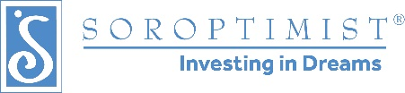
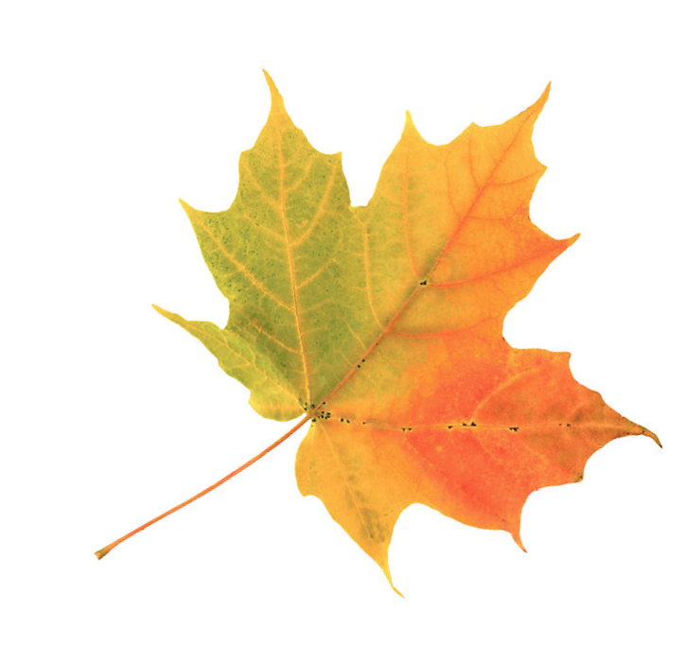
Soroptimist International of Chehalem Valley
Fundraising Committee
Sally Dallas, 503.538.0888
115 N College St, #3
Newberg, OR 97132
www.sicv.org

Soroptimist International of Chehalem Valley’s 6th annual Soup’s On will be a bit different this year. We will be holding on online auction event using a Soup’s On Album on our Soroptimist Facebook. More than ever we will need to raise funds for our scholarships and awards. Your donation towards our auction event would be very appreciated. Donators and Sponsors will be acknowledged in the program, media, and other formats.

Why Women and Girls?
Soroptimist means “best for women” and that’s what we strive to be—an organization of women at their best empowering other women to be their best. As a volunteer organization of business and professional women we feel uniquely qualified to help women and girls live their dreams
It’s true that both women and men live in poverty, face discrimination and must overcome obstacles. But throughout history—in every country in the world—women and girls face additional obstacles and discrimination solely because of their gender.

Soroptimist International of Chehalem Valley will be using the money raised at our Soup’s On event to fund our “Live Your Dreams” award which assists women who provide the primary source of financial support for their families by giving them the resources they need to improve their education, skills and employment prospects. It also goes towards funding other programs and fundraising efforts.

The Soroptimist mission is to improve the lives of women and girls,
in local communities and throughout the world.

Thank you for your generous donation of fine wine to Soup’s On.

Respectfully,

Sally Dallas,
Fundraising Committee, Soroptimist International of Chehalem Valley

P.S. – Soup’s On will be October 1st through the 31st We would love to receive your donation by September 15th. You can deliver to Sally at My Personal Framer or contact Sally Dallas to arrange pick-up.

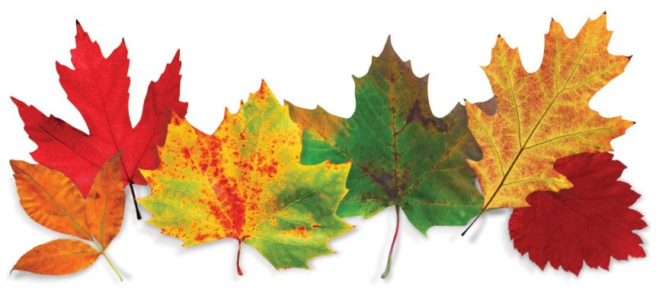
My Personal Framer, 115 N College St, Newberg OR 97132.
You can also drop at the Newberg Steel and we will pick it up from there.
Soroptimist is a 501(c)(3) and all donations are tax deductible.
Tax ID #: EIN 27-1034885

